# Create the resource group

az group create --name chatapp-RG --location australiaeast

# Create the virtual network with the FrontendSubnet

az network vnet create --resource-group chatapp-RG --name chatappVnet --address-prefix 10.0.0.0/20 --subnet-name FrontendSubnet --subnet-prefix 10.0.1.0/24

# Create the BackendSubnet in the existing virtual network

az network vnet subnet create --resource-group chatapp-RG --vnet-name chatappVnet --name BackendSubnet --address-prefix 10.0.2.0/24

# Create the DatabaseSubnet in the existing virtual network

az network vnet subnet create --resource-group chatapp-RG --vnet-name chatappVnet --name DatabaseSubnet --address-prefix 10.0.3.0/24

# Create Frontend NSG

az network nsg create --resource-group chatapp-RG --name FrontendNSG --location australiaeast

# Create Backend NSG

az network nsg create --resource-group chatapp-RG --name BackendNSG --location australiaeast

# Create Database NSG

az network nsg create --resource-group chatapp-RG --name DatabaseNSG --location australiaeast

To add a Network Security Group (NSG) to a network interface (NIC) and configure inbound and outbound rules, you can use the following steps.

**Step 1: Associate NSG with NIC**

You can associate the FrontendNSG, BackendNSG, or DatabaseNSG with the respective NIC by using the az network nic update command.

**Command to associate NSG with NIC:**

bash

# Associate FrontendNSG to the frontend NIC

az network nic update --resource-group chatapp-RG --name chata8c5eNic-67896036 --network-security-group FrontendNSG

# Associate BackendNSG to the backend NIC

az network nic update --resource-group chatapp-RG --name chatappVnet-nic01-332092a3 --network-security-group BackendNSG

# Associate DatabaseNSG to the database NIC

az network nic update --resource-group chatapp-RG --name chatappDBVMVMNic --network-security-group DatabaseNSG

**Step 2: Add Inbound and Outbound Rules to NSG**

Now that the NSGs are associated with the NICs, you can create additional inbound and outbound rules for the NSGs.

**Command to add inbound and outbound rules:**

1. **FrontendNSG (for frontend NIC):**

bash

# Inbound rule to allow HTTP traffic from any source on port 80

az network nsg rule create --resource-group chatapp-RG --nsg-name FrontendNSG --name AllowHTTPInbound --priority 100 --direction Inbound --access Allow --protocol Tcp --destination-port-range 80 --source-address-prefixes "*"

# Outbound rule to allow traffic to the backend on port 8000

az network nsg rule create --resource-group chatapp-RG --nsg-name FrontendNSG --name AllowFrontendToBackendOutbound --priority 200 --direction Outbound --access Allow --protocol Tcp --destination-port-range 8000 --destination-address-prefixes "10.0.2.0/24"

1. **BackendNSG (for backend NIC):**

bash

# Inbound rule to allow traffic from frontend on port 8000

az network nsg rule create --resource-group chatapp-RG --nsg-name BackendNSG --name AllowFrontendToBackendInbound --priority 100 --direction Inbound --access Allow --protocol Tcp --destination-port-range 8000 --source-address-prefixes "10.0.1.0/24"

# Outbound rule to allow traffic to frontend on ports 80 and 8000

az network nsg rule create --resource-group chatapp-RG --nsg-name BackendNSG --name AllowBackendToFrontendOutbound --priority 200 --direction Outbound --access Allow --protocol Tcp --destination-address-prefixes "10.0.1.0/24" --destination-port-ranges 80 8000

1. **DatabaseNSG (for database NIC):**

bash

# Inbound rule to allow MySQL traffic on port 3306 from frontend and backend subnets

az network nsg rule create --resource-group chatapp-RG --nsg-name DatabaseNSG --name AllowMySQLInbound --priority 100 --direction Inbound --access Allow --protocol Tcp --destination-port-range 3306 --source-address-prefixes "10.0.1.0/24" "10.0.2.0/24"

# Outbound rule to allow all traffic from database subnet

az network nsg rule create --resource-group chatapp-RG --nsg-name DatabaseNSG --name AllowDatabaseOutbound --priority 200 --direction Outbound --access Allow --protocol Tcp --destination-address-prefixes "*" --destination-port-ranges "*"

**Recap of What These Commands Do:**

* **NSG association with NIC**: The az network nic update command associates an NSG with a NIC.
* **Inbound rules**: These allow specific traffic to come into the virtual machine or service.
* **Outbound rules**: These allow traffic to leave the virtual machine or service.

These commands should allow you to configure NSGs for your NICs with the desired rules for your three-tier architecture.

VMSS:-

**Frontend nginx:-**

az vmss create --resource-group chatapp-RG --name chatappcli_FEVMSS --image "/subscriptions/f78b1160-ac53-46e6-b77c-be73847ecb68/resourceGroups/chatapp-RG/providers/Microsoft.Compute/galleries/chatappgallary/images/chatappcli-FE/versions/0.0.5" --upgrade-policy-mode automatic --admin-username sysadmin --admin-password Himanshu@2001 --instance-count 1 --location australiaeast --vnet-name chatappVnet --subnet FrontendSubnet

**Backend django:-**

az vmss create --resource-group chatapp-RG --name chatappcli_BEVMSS --image "/subscriptions/f78b1160-ac53-46e6-b77c-be73847ecb68/resourceGroups/chatapp-RG/providers/Microsoft.Compute/galleries/chatappgallary/images/chatappcli-BE/versions/0.0.5" --upgrade-policy-mode automatic --admin-username sysadmin --admin-password "Himanshu@2001" --instance-count 1 --location australiaeast --vnet-name chatappVnet --subnet BackendSubnet

**Database mysql;-**

az vm create --resource-group chatapp-RG --name chatappDBVM --image "/subscriptions/f78b1160-ac53-46e6-b77c-be73847ecb68/resourceGroups/chatapp-RG/providers/Microsoft.Compute/galleries/chatappgallary/images/chatapp-DB/versions/0.0.5" --admin-username sysadmin --admin-password "Himanshu@2001" --size Standard_B2s --vnet-name chatappVnet --subnet DatabaseSubnet --location australiaeast --security-type TrustedLaunch

**loadbalancer:-**

Here are the commands to create the load balancer, backend pool, health probe, and load balancing rule for your backend VMSS chatappcli_BEVMSS in one line for each:

**1. Create the Load Balancer:**

bash

az network lb create --resource-group chatapp-RG --name chatappcli-BELB --sku Basic --location australiaeast --vnet-name chatappVnet --subnet BackendSubnet --private-ip-address 10.0.3.10

**2. Create the Backend Pool:**

bash

az network lb address-pool create --resource-group chatapp-RG --lb-name chatappcli-BELB --name chatappcli-BEVMSS_b54c76d7

**3. Create the Health Probe:**

bash

az network lb probe create --resource-group chatapp-RG --lb-name chatappcli-BELB --name chatappcli-BEVMSS_HealthProbe --protocol tcp --port 8000 --interval 5 --threshold 2

4. **Create Load Balancing Rule:**

az network lb rule create --resource-group chatapp-RG --lb-name chatappcli-BELB --name chatappcli-BEVMSS_LBRules --protocol tcp --frontend-port 80 --backend-port 8000 --frontend-ip-name LoadBalancerFrontEnd --backend-pool-name chatappcli-BEVMSS_b54c76d7 --probe-name chatappcli-BEVMSS_HealthProbe

**applicationgateway:-**

az network public-ip create --resource-group chatapp-RG --name FE-applicationgateway-publicip --allocation-method Static --sku Standard --location australiaeast

az network application-gateway create --resource-group chatapp-RG --name chatappcli-applicationgateway --sku Standard_V2 --capacity 2 --vnet-name chatappVnet --subnet applicationgateway --location australiaeast --public-ip-address FE-applicationgateway-publicip

az network application-gateway http-settings create --resource-group chatapp-RG --gateway-name chatappcli-applicationgateway --name FE-applicationgateway-httpSetting --port 80 --protocol Http --cookie-based-affinity Disabled

az network application-gateway http-listener create --resource-group chatapp-RG --gateway-name chatappcli-applicationgateway --name FE-applicationgateway-httpListener --frontend-port 80 --frontend-ip FE-applicationgateway-publicip

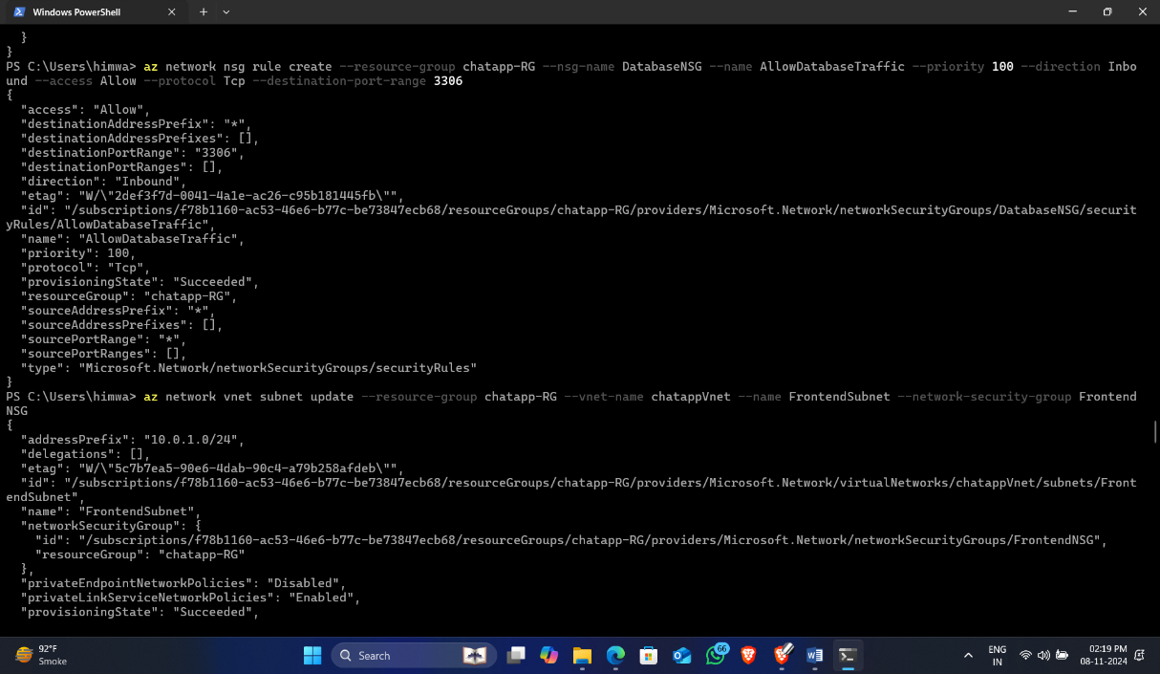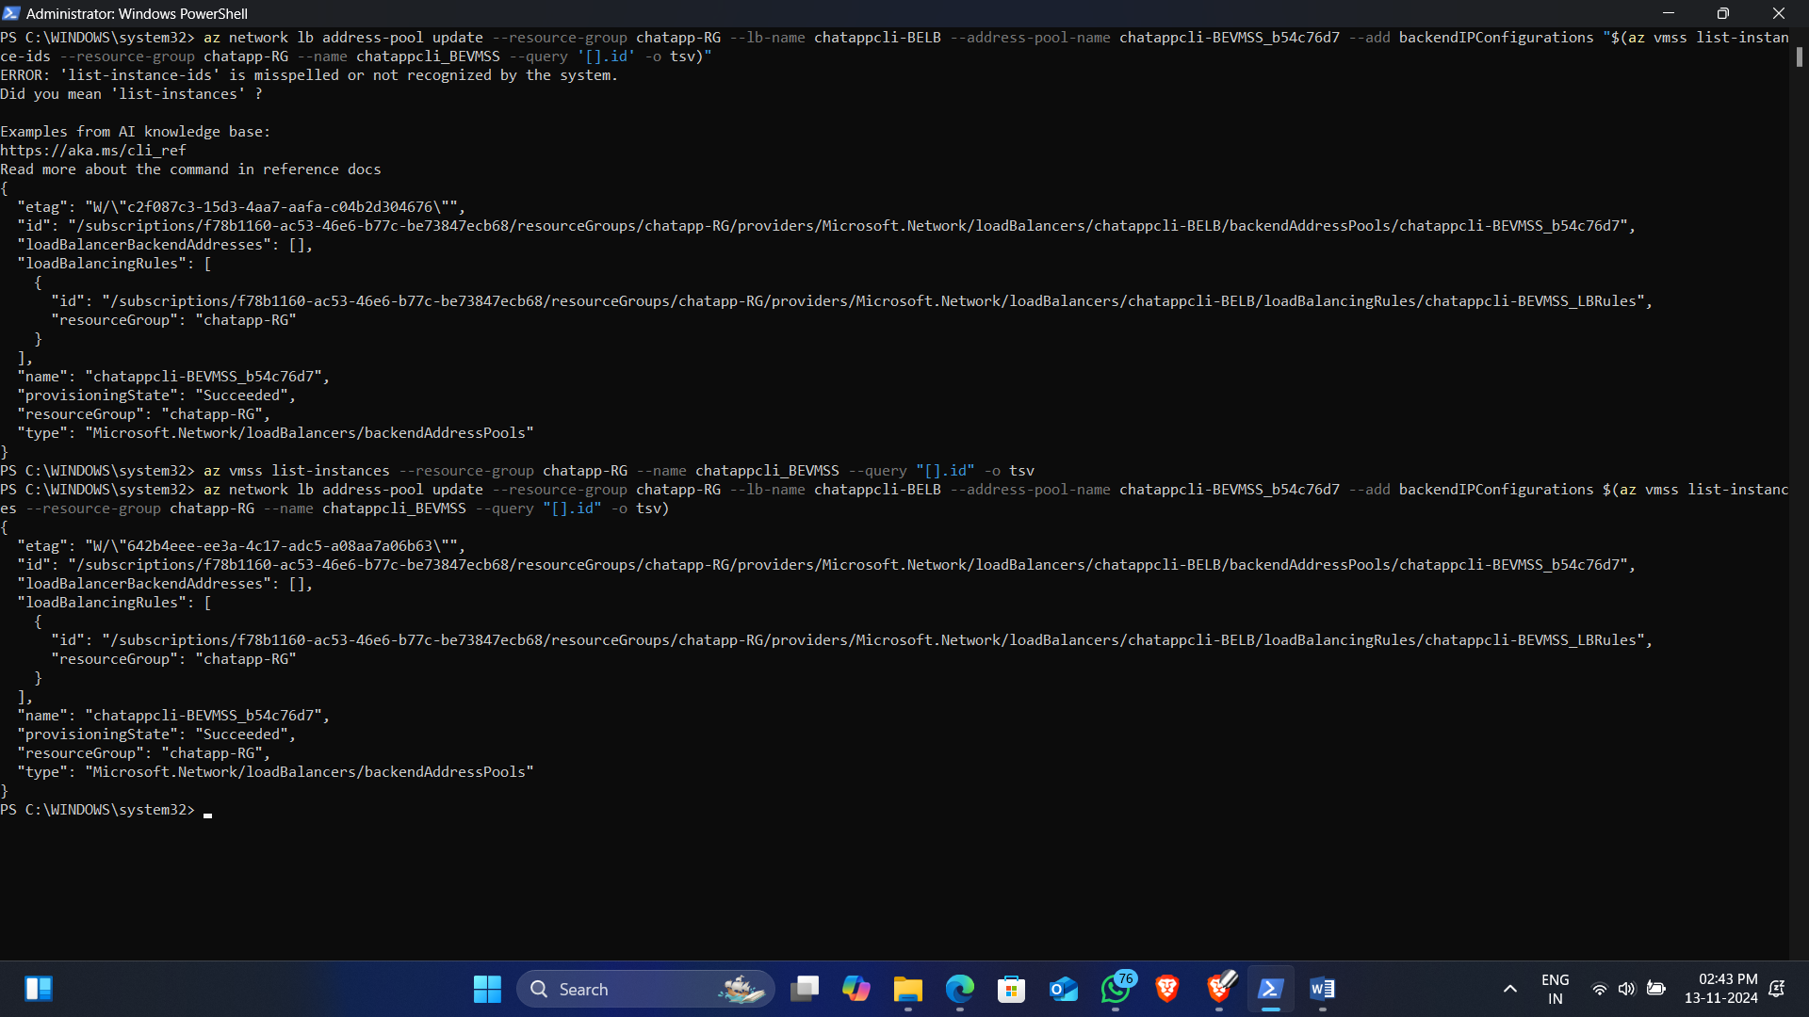az network application-gateway rule create --resource-group chatapp-RG --gateway-name chatappcli-applicationgateway --name FE-applicationgateway-rule --http-listener FE-applicationgateway-httpListener --rule-type Basic --address-pool FE-applicationgateway-backendpool --http-settings FE-applicationgateway-httpSetting --priority 100

